PRESS INFORMATION

Volvo CE brings 95-tonne class rigid hauler to the worldwide market

Volvo CE has expanded the distribution of its proven 95 tonne (105 ton) R100 rigid hauler. The move comes thanks to the addition of a Stage V/Tier 4 Final certified engine.
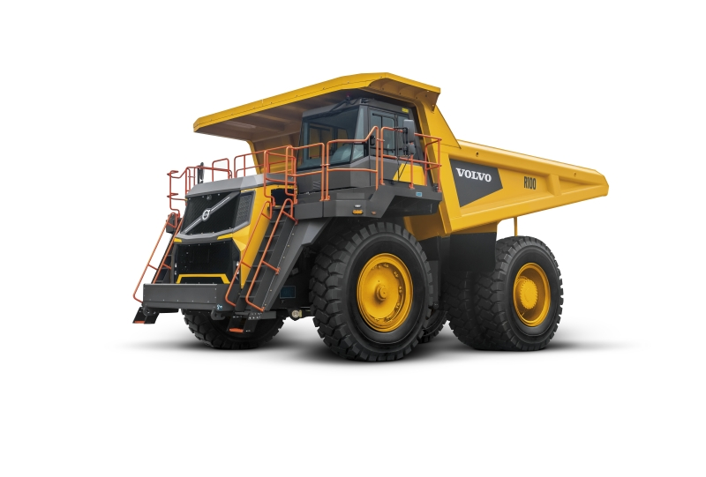

Proven on jobsites throughout the world, the R100 rigid hauler from Volvo Construction Equipment (Volvo CE) is now fitted with a Stage V/Tier 4 Final engine, allowing it to enter the strictest emissions regulated markets and opening up worldwide distribution. With a size and capacity that make it the largest hauler in the company’s line-up, the R100 rigid hauler promises to drive down operating costs for customers by boosting productivity, fuel efficiency, operator comfort and uptime.

Power comes courtesy of a premium 783 kW (1,075 hp) Stage V/Tier 4 Final engine, with a combined drivetrain that provides high torque capabilities, unparalleled pulling functionality and class-leading rim pull, for optimum performance. Drivetrain performance is supplied by the Volvo Dynamic Shift Control which automatically installs optimum gear selection, speed and torque for proven fuel efficiency.

Customers can expect to spend less per haul with the R100, featuring a 79 yd³ (60.4 m³) capacity dual-sloped body for optimum load retention and minimal load shift. The load profile policy enables the operator to meet a consistent average target payload, while the body-tipping fast cycle time ensures all-round efficiency. The Stage V/Tier 4 Final R100 includes a selectable Economy shifting mode for lighter working applications or high-speed applications, an auto-idle engine shutdown feature with adaptable timing that cuts unnecessary engine idling to reduce engine wear and operating costs.

Volvo builds on the high capacity and hauling performance of its rigid hauler with intelligent monitoring systems. The On-Board Weighing (OBW) option ensures the machine moves the maximum safe payload, for a cost-effective production.

The R100 is available with CareTrack – Volvo’s telematics system – to remotely monitor operational data, including fuel consumption, machine utilization, idling reports and GPS position.

Customers interested in increasing the productivity of existing and future projects have access to Volvo Site Simulation, with the help of their local Volvo dealer. The tool helps to define the most profitable fleet of equipment, site configuration and project results based on customer needs. By using the simulation, customers and dealers can work together to put an equipment plan in place before a project begins.

Durable by design

Uptime and productivity are centered on the machine’s durable design, which promotes high component protection, longer lifecycles and extended intervals between planned maintenance.

With a body manufactured from high impact and high abrasion-resistant 400-HBW-hard steel, connected to a strong durable frame, the R100 rigid hauler achieves long-lasting performance utilizing:
- Low centre of gravity.
- McPherson dynamic smooth riding front suspension.
- Specifically designed wheel track and wheel base to install excellent machine stability that smooths out all surface shocks.
- ‘Horse collar’ frame design provides torsional flexibility for high durability while traveling on uneven terrain.
- Frame designed with suspended mount tanks and sleeved bores for high structural durability and reliability.

The operator’s choice

The R100 also brings operator productivity and safety to the forefront – starting with the ROPS/FOPS-certified operator cab, combined with the anti-slip steps and walkways that provide a safe entry to the machine. Offering reduced vibrations and exterior noise, the cab is bolted onto viscous-type isolation mounts; it combines with the dynamic McPherson type front suspension to provide excellent operator ride comfort.

From the operator seat, the operator can observe the job site and surrounding areas through the large glass area and low rake windscreen. Good visibility is complemented by a 360° awareness system provided by Volvo Smart View. The system uses multiple ultra-wide angle exterior-mounted cameras to produce a bird's-eye-view of the vehicle and surrounding work area via the on-board display.

On top of the low-effort steering system, all displays and ergonomically positioned fingertip controls are within reach of the fully adjustable Volvo air suspension seat, easily adjusted to fit the operator’s physique.

For high levels of speed control and machine navigation the R100 is equipped with two retardation systems. When manually selected, the transmission retarder slows the drivetrain that will limit wheel lock-up on steep declines and in wet conditions. While the modulating braking retarder can be activated automatically when the operator’s foot is off the accelerator to maintain a gear selected constant downhill engine speed control. These functions reduce operator input for easier operation. A host of other systems further contribute to high levels of automated safety, protecting both operator and machine. These include neutral coast inhibitor, engine overspeed protection, as well as secondary brake and steering systems.

Maintaining good order

Packed with durable features that provide superior protection, the R100 optimizes operations and extends maintenance intervals for lower operational costs. When it’s time for servicing, The R100 service points are methodically positioned to complete maintenance swiftly and efficiently.

These methodically positioned service points are grouped and located within reach from the ground and service platform, while the direct rim-mounted wheel design promotes safe and quick installation and removal. Maintenance is further supported, with a suite of on-board information including system pressures, temperatures and fault reporting.

Last but not least, the R100 features a high degree of filtration for better performance and to prolong component life. Each functional system on the hydraulics has magnetic suction filters, as well as a pressure filtration on the steering, brake actuation pump and brake cooling units. The engine-mounted primary and secondary fuel filters combine with the advanced two stage oil filtration to remove harmful contamination. And an aspirated engine air intake filters promotes cleaner air intake and longer filter life.

The R100 is the perfect partner for mining and quarrying applications. It’s waiting for you at your local Volvo dealership.

Key specifications:

Payload capacity kg /lb. | 95000 / 209,439
Body Volume, SAE 2:1 heap m3/ y3 | 60,4 / 79
Net weight kg /lb. | 69752 / 153,777
Gross weight kg /lb. | 166 280 / 366,584
Engine | Cummins QST30 (Tier 4 final certified)
Maximum engine gross power kW / hp | 783 / 1,050
…at engine speed r/min | 2100
Max SAE J1349 gross torque Nm / lbf ft | 4 631 / 3,416
…at engine speed r/min | 1300
Max speed km/h / mph | 50 / 31.1

October, 2021

