PRESS INFORMATION

EC350E launch firmly establishes the 35t excavator segment

All-new excavator extends Volvo CE’s mid-sized range, featuring outstanding versatility, efficiency, and productivity to hit the general-purpose sweet spot.

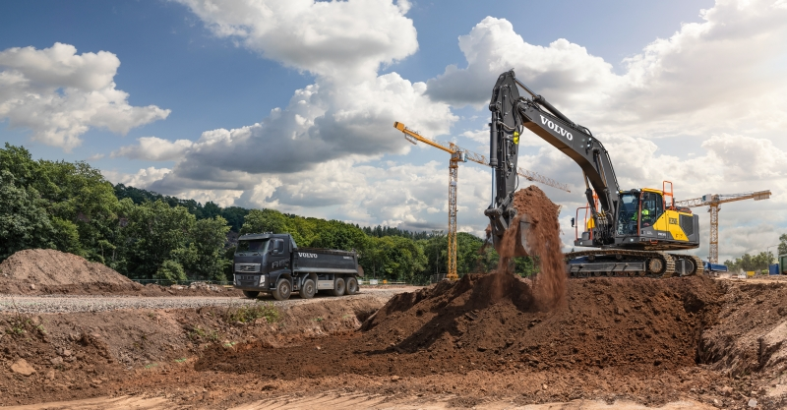

The all-new EC350E from Volvo Construction Equipment (Volvo CE) has been designed to perfectly bridge the performance profile of the company’s existing EC300E and EC380E excavator. The 35-tonne excavator is the go-to guy for general construction duties. With a total height of under four meters when loaded on a trailer, it can be transported without dismantling – taking the hassle out of site moves.
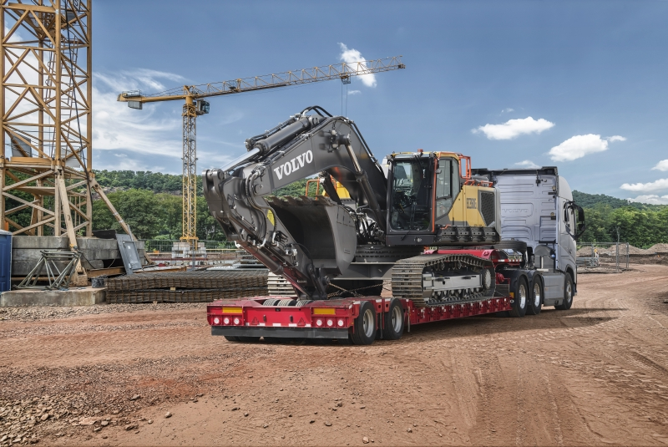

As well as being optimally sized this versatile machine can be adapted to suit a wide range of jobs in no time at all. Operators can select several functions depending on the task at hand and their preferences. This includes boom/swing and boom/travel priority, enabling one function to take the lead over another. The boom-down speed can also be adjusted, giving added control for tasks that require extra precision. A range of matched Volvo Attachments enable the job to get done with optimum productivity, efficiency and performance.

Efficient and comfortable
Long days in the cab are made less stressful thanks to boom-and-arm bounce reduction technology – lessening machine shocks. The Comfort Drive Control option helps reduce fatigue by enabling operators to steer the machine using the joystick rollers instead of the pedals. There are also customizable settings that include a ‘long push’ functionality on the joystick, allowing operators to set an additional shortcut function.
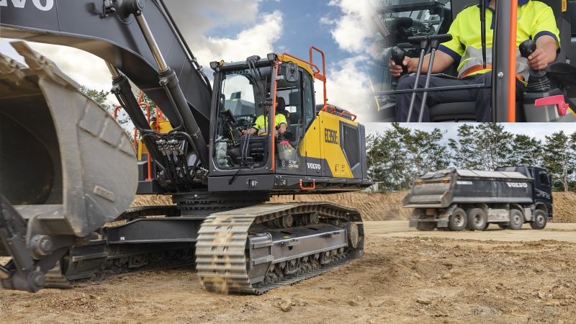

Operators are further assisted in their tasks by the optional Dig Assist apps – powered by the 10in. Volvo Co-Pilot tablet. These include 2D, In-Field Design, 3D software packages, and On-Board Weighing. Not forgetting Volvo Active Control, which automates boom and bucket movements, making digging twice as fast. With Volvo Active Control, operators can also set swing fence, height limit, and depth limit. This helps to avoid contact with side obstacles, overhead obstacles such as power lines, and underground hazards such as pipes and cables.

Safety first
Safety is enhanced by bolted anti-slip steps, high visibility handrails as well as the ergonomic, low-noise, and low vibration Volvo Care Cab. When it comes to accessing the upper structure, operators can be confident thanks to the 3-point right-hand side access. Visibility is at the heart of safety: the low machine hood design contributes to best-in-class eyelines to the side and rear of the machine from the operator’s seat. Visibility is boosted further thanks to rear and side cameras, along with the optional all-round Volvo Smart View.
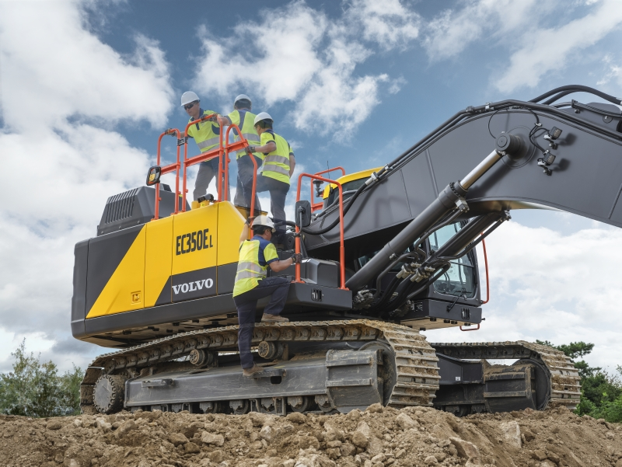

Low operating and maintenance costs
The EC350E delivers class-leading fuel efficiency, thanks to a combination of features that includes the classic ECO mode, selectable work mode and intelligent electro-hydraulics. The D8M Volvo engine features a power rating of 1,600 rpm while delivering impressively high torque at low rpm, and comes fitted with auto-idle and shutdown to help reduce unnecessary fuel use.

With auto-regeneration technology, the machine doesn’t need to be stopped to clean the diesel particulate filter. Additionally, the hardworking (and hot) turbo-chargers are carefully cooled, thanks to an optional delayed engine shutdown feature, which helps avoid overheating and increases the machine’s reliability. Also contributing to increased machine reliability is the electro-hydraulic system, which requires fewer hoses than is normal – reducing the need for couplings and minimizing maintenance requirements.

Time and maintenance costs are further reduced, due to the engine oil and filter change intervals of 1,000 hours, as well as ground-level access to grouped filters. And when the urea needs topping up the new splash guard makes filling quicker and easier – while also reducing the risk of spillage and subsequent corrosion.

Working harder for longer
Volvo CE’s portfolio of Uptime Services is key to ensuring long term machine performance. Oil Analysis, Care Inspection, and Undercarriage Inspections help keep machines in top condition, while easy-to-read reports – powered by CareTrack telematics system – help owners track productivity, fuel efficiency, and machine condition. For even less hassle Volvo Uptime Centers monitor the machine and notify customers, if required. This service is called Volvo Active Care.

Combining versatility and efficiency with ease of operation and simple maintenance, the EC350E is designed to help customers get maximum profitability of their general construction projects.

Key specifications:
Operating weight | kg | 34 690 - 40 600
 | lb | 76,478 - 89,508
Gross power | kW | 220
 | hp(imp) | 295
. . . at engine speed | r/min | 1600
Bucket capacity | m3 | 0.87 - 2.33
 | y3 | 1.14 - 3.05
Lifting capacity, along undercarriage | kg | 13 470
 | lb | 29,7
. . . at reach / height | m | 6.0 / 1.5
 | ft | 20' / 5'
Max. digging reach | mm | 11 123
 | ft in | 36'6''
Max. digging depth | mm | 7 490
 | ft in | 24'7''
Breakout force, SAE J1179 (Normal) | kN | 177
 | lbf | 39,791
Breakout force, SAE J1179 (Boost) | kN | 192
 | lbf | 43,163
Tear out force, SAE J1179 (Normal) | kN | 201
 | lbf | 45,187
Tear out force, SAE J1179 (Boost) | kN | 219
 | lbf | 49,233
Overall width | mm | 3 190
 | ft in | 10'6''
Tail swing radius | mm | 3 600
 | ft in | 11'10''
Based on machine configuration: EC350E L; Boom 6.45m; Arm 3.2m

Ends.
December 2020

